Abgabe Übung Nr. 2 Informatik 3
Jakob Lagaly
Quang Vu Tuyen
WS 17/18

Use-Case-Diagram:
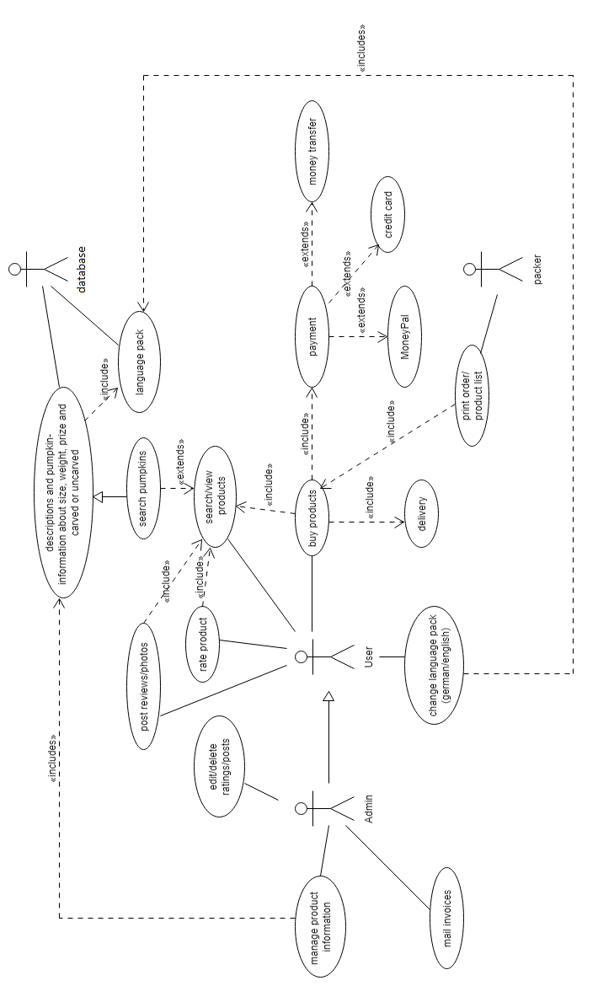
Use-Case Examples:

Name | Pay for a product
Precondition | User has chosen a product, clicked on checkout and has a credit card, a MoneyPal account or the needed information of his bank account (IBAN, BIC etc.)
Sequence of steps | 1. User has chosen a product.  2. User clicks on „checkout“.  3. The homepage shows the payment method selection page.  4. User chooses the payment method.  5. The homepage shows the form for the given payment method.  6. User fills out the form (e.g. email and password for MoneyPal account).  7. User clicks on „buy/pay“.  8. The homepage asks if the User is sure he wants to precede.  9. User clicks on „yes“.  10. If (enough money) money transfer will initiate.  11. Else (Error).  12. The homepage shows the bill and the confirmation of payment.
Postcondition | User has payed for his chosen product and the product is now „ready“ for delivery.

Name | Print order/product list
Precondition | User has chosen a product and payed for it and information about the purchase is available to the packer.
Sequence of steps | 1. User pays for products/a product.  2. Packer has time and products are in stock.  3. Packer prints out product list.
Postcondition | The packer now has all the available information to pack the package and send it to the customer/user.

Class-Diagram:

